1:48 scale Spanish/Southwestern Style Vignette
Items needed to complete project:
Paper towels
Paint Brushes including one stipple or stencil brush and foam brush
Paint; terra cotta, pumpkin, paprika, brown, tan and others of your choosing
Glue
Masking tape or clamps
Wallpaper glue
Small sharp scissors
Tweezers
Pin vise or small nail
Clear sealer
Round hole punch (optional)
Oval hole punch (optional)

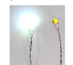
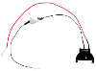
Items included in this kit:
4” x 4” Glass dome
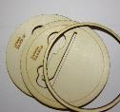
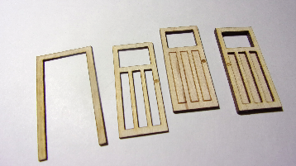
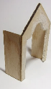
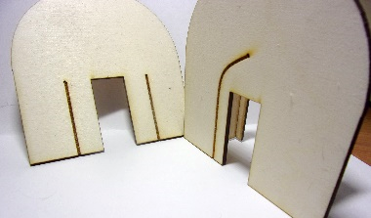
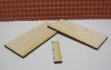
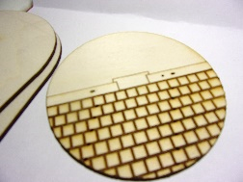
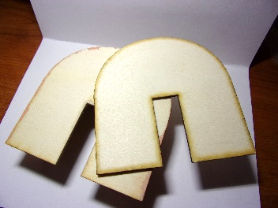
Battery cell with LED light
front
E
D

back
F

C

A
B
2 pico lights

- 3 piece wood base with coin cell battery cut out
B. Center dome structure – 1/8” liteply
C. Center dome base with engraved
tile flooring – 1/16” maple
D. Portico pieces – 2 sides and front – 1/16” maple
E. Doors and overlay pieces (4) Door trim (2)
F. Roof and plastic barrel roofing
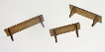
Kits:
Laser cut benches Laser cut benches
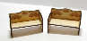
3D printed items:
Cactus planters and pottery
Overhead lamp
2 scones
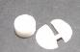
2 chairs
1 table
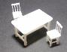
Other:
Sand/stones
Plastic barrel roof
Grout
Plastic for window in door
Felt pads for bottom

Please read all directions first including the tips that follow
I show pictures of the colors I chose but feel free to use colors of your choosing.
Directions:

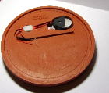
Prepare and paint pieces.

Glue three base pieces together-- the 2 marked and one ring,
making sure all the edges are flush especially the two cutouts
in the middle, they must be flush!, clamp and let dry.
Lightly sand edges until smooth. Paint base pieces.
(I used paprika), be sure to get inside the ring (it will show through glass)
and all along outside.

Fit the battery pack into the holes with the on/off switch facing downward. Lightly sand if necessary to get snug fit. The battery should sit nicely and not fall through the hole but be able to switch out batteries when needed. Set aside.
Paint or stain doors and overlays. Glue overlays on top of door and let dry. Dry fit door into opening. Sand to fit if necessary. They are precision cut to fit the opening but sometimes painting causes them to swell a bit. Be sure to paint or stain the edges of the walls. Do not glue doors yet!

Cut acetate to fit outside the window opening. Use acetate sheet between the two doors. Add door knob of your own choosing. Set aside until final assembly.

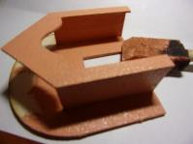

Paint individual pieces first before gluing.
Add paint to the non-sanded grout
to get a thick paste. Use a foam brush to coat
all exterior walls. Then tap the foam brush up and
down lightly to give a texture.

Be sure to paint outside edges, they will be very visible in final assembly.
Assemble portico, let dry, then sand the sharp corner in front
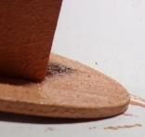
to more of a rounded corner. Measure 11/16” from the
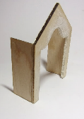
edges of the outside going toward the center.
This is where you will glue the portico to the wall.
Glue edges of portico to the outside wall piece
(This one a single channel engraved on the back
that runs form the top to the bottom.)
Tape or weight it and let dry.
Sand corners

Paint Floor tiles

I first used a tan that would be close to sand on the
outside half of the base.

(Note the holes drilled on either side of the door opening
are for running wire from light through flooring to base.

You may choose your own colors, but here is what I did:

I dabbed various colors of terra cotta, paprika and
some orange using a stiff brush to get slight variations of
color and texture on the indoor terra cotta tiles.

Let dry.
Adding grout removing grout with damp paper towel

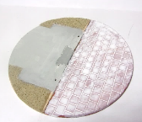
Coat with clear matt sealer or varnish. Let dry.
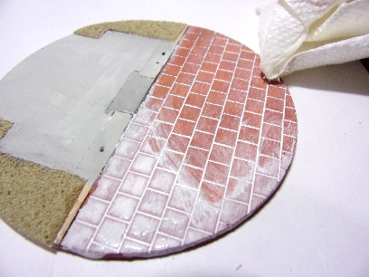
I then painted a “sidewalk” with light grey.

Add white paint to non-sanded grout and coat
over the tiles, making sure to get into the
grout lines. Let dry. Use damp paper towel
to remove from tiles. Seal tiles with clear sealer.

Exterior lighting:
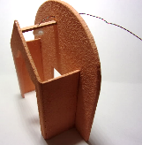

Glue brace across the front peak. Glue overhead lamp shade to bottom of brace lining up the holes. Let dry, clear away any glue that may have gotten into hole. Insert wire from LED light up through the fixture through hole in brace, along top of brace and through hole in outside wall. Run wire down channel engraved on back and secure wire in place with glue or tape. The wire will continue down through holes in flooring to connect with battery underneath as one of the final steps. You may want to connect to battery now to test it then disconnect it and continue with directions.

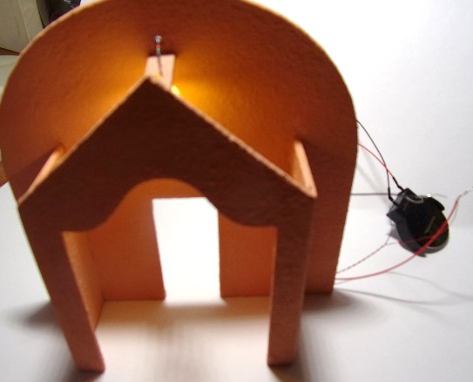
Cut out pattern from paper for roof of portico measuring around the roof pieces. Use pattern to cut plastic barrel roof pieces. Cut a 1 2/8” thin strip of one line of the barrels to go over the peak of the roof.

Glue roof in place. I painted the edges of mine the same color as the roof pieces. Glue plastic barrel sheets over the portico’s roof. Glue a thin strip of just one line of barrels to cap off the peak where the raw edges meet.

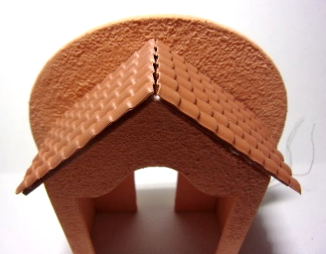

Interior lighting:
Wires glued to channels in back
Pico light bulb peeking out from hole
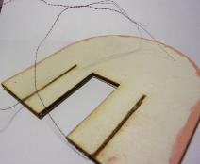
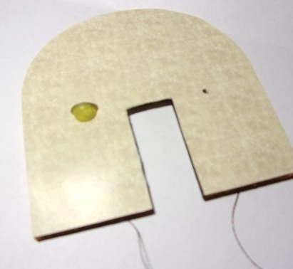

Wallpaper interior, trim to the edge
of rounded dome piece, cut out door
opening. Poke hole from back of wall
to front.

Glue pico lights peeking out from holes.
Paint wall scone with gallery glass for
warm yellow or leave as is for brighter
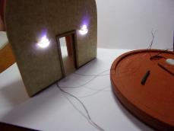
white. Glue the sconce over the pico
light making sure the light is in the
indentation of the scone. Also be sure the
flat part of the scone is facing up.

Glue or tape wire down the engraved
channel on back of wall. Let dry.
Twist red wires together and green wires
together to test to make sure your lighting works.
Untwist and wait for final assembly to secure.

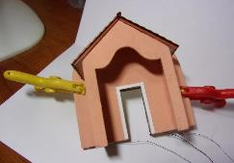
Assemble Vignette

Glue door trim pieces around doorway
in front and back.

Glue back to front, clamp and let dry.

Glue door in place.
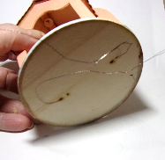

Finish Lighting:

Insert wires from lights into holes in base. With a little bit
of “give” run glue along the walls and portico pieces and glue
in place over the center line. Pull wires tight and let dry.

To connect the wire from the bulbs to the wire from the battery,
slide one black shrink tube down the red wire and one down the
black wire. Twist red wire together and twist black/green wires
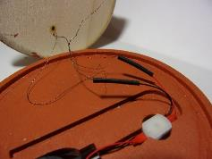
together. Turn on switch to check lights. Once satisfied with light
use heat source on the shrink tube to secure. (It will melt down to
encase the wire connection and help secure it.)

Glue felt pads to bottom of base to raise it so that the
light switch is not protruding past the entire piece once
set down. You want to be able to pick up the finished
dome and click the on off switch.

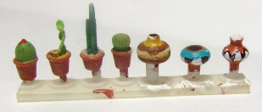
Now it is time to decorate and accessorize:

Paint cactus and pots. Clip from tabs with sharp scissors.

Color Inspiration

Punch out plates with regular hole punch and platters with oval punch or cut by hand with small sharp scissors. Cut out selected art work if desired and seal with clear sealer

Glue shelving brackets to underside of shelves, paint or stain. Add cactus, plates or other décor, then glue to interior wall.

Paint tables and chairs. Add table runner, dishes or other decorations of your own.

Add a patterned rug under the table or use rug to hang on wall.

Arrange furniture pieces in interior as desired and glue in place or use sticky wax to adhere.

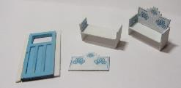
Exterior Finishing

Paint or stain benches and glue inside portico.

I used a west paint swash to have paint seep into
engraved design.

Glue paper sand on base outside of portico,
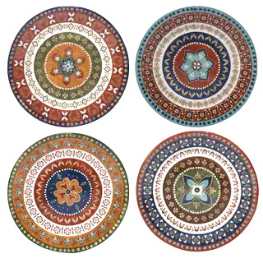
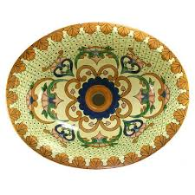
add cactus and/or rocks for landscaping.

Be sure to send me a picture to post on my web site
and thanks for purchasing this kit.
Your feedback and suggestions are welcome.

Shellie Williams
Mini Etchers
www.minietchers.com
Email: Swill123@aol.com

Tips and Hints

Tips for working with laser cut wood:
Laser cut products will have dark, charred edges. It is not necessary to sand the charred surfaces unless you would like to stain the edges. Light sanding with a very fine grit sandpaper will remove some of the dark color.

1. Use a Q-tip cotton bud dipped in denatured alcohol and rub along edges to diminish the "charred" look. This is best when deciding to paint pieces as the residual soot will discolor your paint when painting the edges.

2. Paint the charred cut edge with one coat first. Let dry and then paint entire piece. A second coat may be needed.

I use quality wood –Maple for my kits. But even so, when you paint wood it has a tendency to warp. Paint BOTH sides of the wood, even if it won’t show. This will keep warping to a minimum.

Tips for working with 3d items:
Plastic 3D items are printed using an additive process with plastic being built up layer by laser. White plastic will have a slight “rough” texture to it. Detail plastic will be smooth and semi-transparent.

Items can be painted with Tester’s paints, (or any paint used on plastic models) acrylics or permanent ink. You can then seal them if desired.

White nylon plastic is the most common material and is the least expensive. It is a bit more flexible which is good to note when removing from any tabs or “burs” that hold individual pieces along a base with other pieces.

Detail plastic is more expensive but can get finer details in the model. It is mostly translucent and a bit more brittle so it can snap off the tabs easier. It is also more delicate and must be handled gently to prevent small junctions from breaking.

Many 3D items, especially in smaller scales, are so small they would be impossible to print.
They are not large enough for the machine to print. When I put them on tabs and string a few things together the item can be printed. I like doing this because it saves money and it is easier to paint.

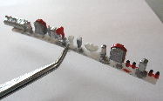
They can be cut from tab with sharp scissor and then trimmed with a sharp single edge razor.
The tabs can also be sanded.

To paint these
Secure with locking tweezers or alligator clamp then paint. Clip from
tab using small sharp scissors. If any of the tab remains on the bottom
cut with scissors or, shave off with razor. Be mindful of handles and
small parts. Do not grasp them when shaving a piece or they will break!

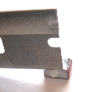
Tips for painting with gallery glass
Gallery glass is more translucent than other paints and can be used
on 3D printed items for clear effects such as on light fixtures and
for water effects.

On light fixtures, a single thin layer of yellow or gold will give the
illusion of a light that is on. More than one coat of gallery glass
and the paint is no longer translucent so use a very fine thin coat.

