1:48 Scale Moroccan Courtyard Vignette
Items needed to complete project:
Q-tips
Denatured alcohol (optional)
Paper towels
Assorted paint brushes
including foam brush
Paint, various blues, white,
metallic, and various others
Wood stain
Various colors Sharpie fine point
markers
Various grits of sandpaper
Glue and gluing jig
Small sharp scissors
Hobby knife
Tweezers
Masking tape and clamps

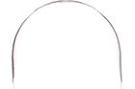
Items included in this kit:
Glass dome
Battery cell with LED Nano light

- 3 piece laser cut wood base with coin cell battery cut out
B
B. Flooring - 1/16” maple
A
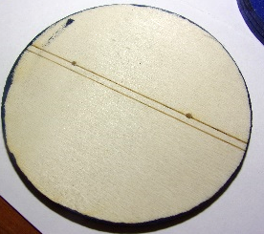
C. Center dome structure walls (one blank,
one engraved light channel on back) – 1/8” lightply
D. Laser cut door frames (inside and outside) 1/32” maple
E. Laser cut doors and door overlays (18 , 8 1/16” maple doors,
12 1/32” maple overlays
F. Door handles (12)

Kits:
C
- Wood low table and side table kits
- Sultan Sofa kit

3D items:
Hookah, tea pot and cups, urn, and tagine
Fountain
Light fixture
D
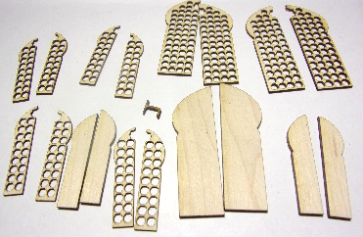
Pouf and pillow
E

Other:
Acetate for window
Wallpaper (2)
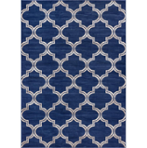
Silk Rug printie
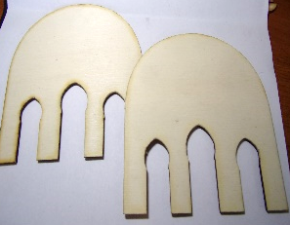
Cushion foam
F
Fabric
Directions:

Prepare laser cut wood for painting and staining (see tips for working with wood on my website.)
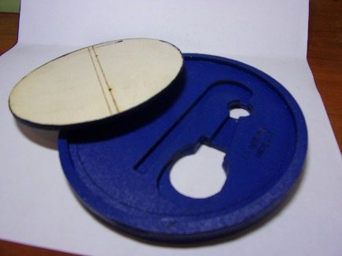
Glue three base pieces together-- the 2 marked and one ring,
making sure all the edges are flush especially the two cutouts
in the middle, they must be flush!, clamp and let dry.
Lightly sand edges until smooth. Paint base pieces.
(I used navy), be sure to get inside the ring (it will show through glass)
and all along outside.

Fit the battery pack into the holes with the on/off switch facing
downward. Lightly sand if necessary to get snug fit. The battery
should sit nicely and not fall through the hole but be able to switch
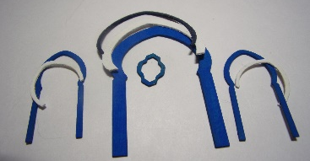
out batteries when needed. Set aside.

Stain or paint door and door overlays.
Door and frames could also be painted color of your choosing.

I painted gold in the upper larger star.
Glue overlay pieces in place. Let dry and set aside.
Overlay for doors
.
Overlay hood for door trims

Paint dome exterior structure walls as desired. I used white.
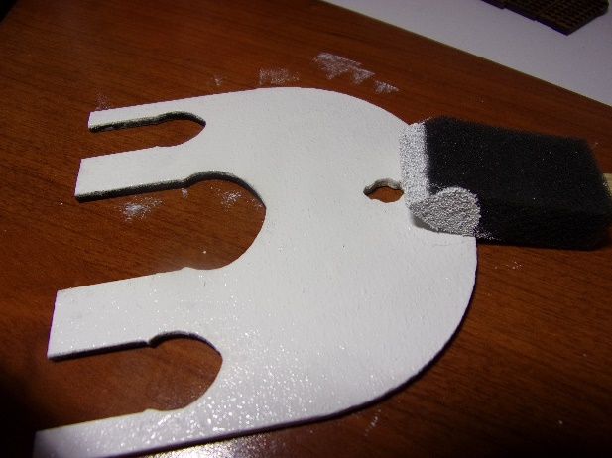
Be sure to paint inside of window cutouts and outside edge of both walls.

For stucco, mix a teaspoon of non- sanded grout with paint color and paint onto front of wall and front and back of all portico pieces. To get a stucco affect, lightly tap a foam brush over the surface. Do this lightly as a heavy hand will leave a texture that is too big. Be sure to check for any lumps. Paint outside edge of both walls.

Glue one side flooring with tile sheet.

Glue opposite side with contrasting tile sheet.
Inspiration:
Sultan Sof or Floor sofa
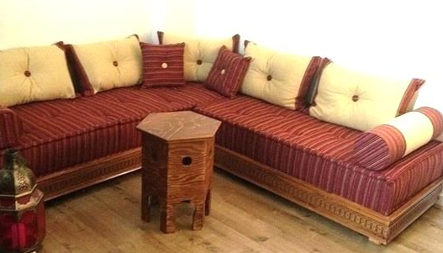

Pillows and greenery in courtyard

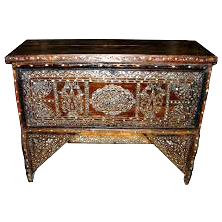

Pouf
tables

Assembly:

Glue acetate behind window opening.

Glue interior window and door frames;

Glue exterior door frames with overlays in place.

Fit doors in opening, if they have been painted or
stained the wood may have swelled and you will
need to sand the opening a bit. Do not glue in yet.

Lighting:
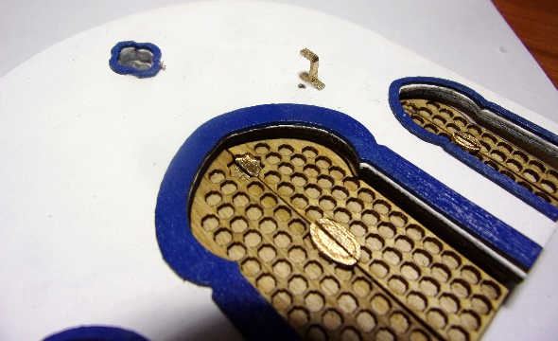
Make an overhead light by gluing bulb to outside
of 3D printed lantern. Wrap the light wire around
the top and around the hook. (I painted mine gold.)

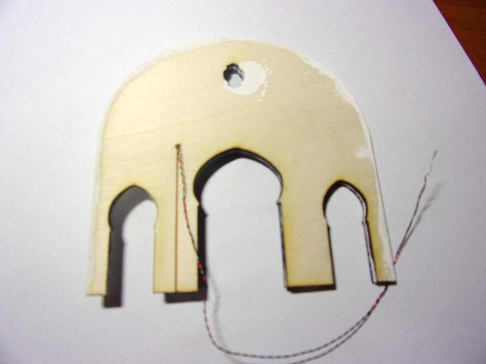

Run wire through hole and down the inside wall and through the hole in flooring to base.

Untwist bulb wire to separate the two colors. Connect the wire from the bulb to the wire from the battery. Twist red wires together, then opposite wire together. Insert battery into coin cell holder and make sure the light works.

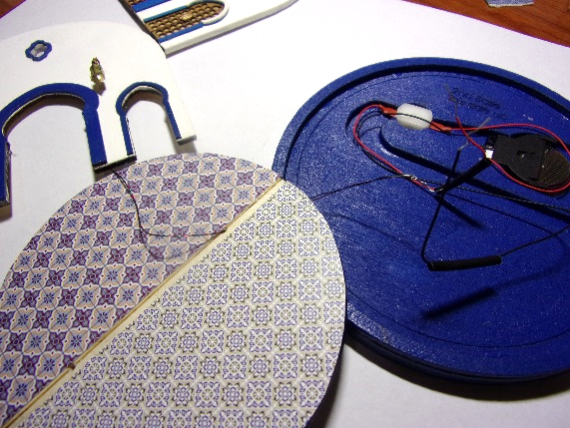
DO NOT GLUE IN PLACE YET!

Continue Assembly:

Glue back wall to front, clamp and let dry.

Glue doors in place centering between the walls.

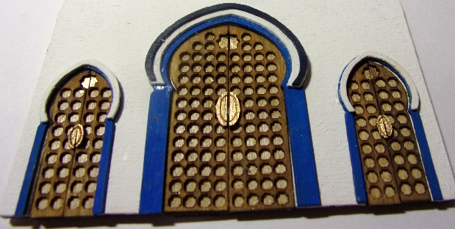

Glue center wall piece on top of floor along engraved line inserting wires from light into hole.

Finish lighting:

Slide one shrink tube down the red wire and one down the black wire. Connect red wires together and twist. Repeat with opposite wire. Click battery switch. If the light does not come on, check the wire connections. Once satisfied with light use heat source on the shrink tube to secure. (It will melt down to encase the wire connection and help secure it.)

Insert on/off button into smaller hole with switch facing down. Run wires along remaining area of slot and secure in place.

Glue felt pads to bottom of base to raise it so that the light switch is not protruding past the entire piece. You want to be able to pick up the finished dome and click the on off switch underneath and it will not be seen from the finished dome vignette.

Now it is time to decorate and accessorize:
Assemble tables as directed on packaging.

Paint or stain as desired. I used thin
Sharpie markers over a painted and sanded table.

Paint pouf and pillow.

Here are some popular Moroccan motifs to
inspire your designs.

Paint hookah, coffee pot, tagine and cups as desired and arrange on table. Add cord to Hookah and paint tip gold or silver.

Suggestion: Tea pot and cups in brass
or gold, tagine popular colors are blues, red and terra cotta.
Use Sharpies to paint designs.

As these pieces are printed in detail
plastic they are transparent and it is
preferable to paint two thin coats for coverage.

Coffee pot handle and spout cut fold, paint and glue to pot
Glue into cone shape then bend along dotted line and glue spout to coffee pot

Paint fountain

Paint outside but be sure to leave bottom clear.
I painted light blue Gallery Glass for water.

Once dry I used Dimensional Magic, but have also used clear sealer to adhere
thin strips of plastic wrap to the bottom of the fountain.
I made three stream flows but you can make as many as you want.
Once dry, flip the plastic wrap up to the top of the fountain and
secure in place with sealer or Dimensional Magic. Trim edges
of plastic wrap as close to water as possible. Once the Dimensional
Magic or sealer dries a little bit you can push the edges of the
plastic wrap up a bit to look like fountain gurgling.

Other ideas:

Hang a tapestry on wall or print out Turkish rugs add flowing gauze curtains, add tea in tea cups or add plates of food on table. Add additional pillows, tapestry and greenery.

Thanks for purchasing this kit. Be sure to send me a picture to post on my web site.

Your feedback and suggestions are welcome.

Shellie Williams
Mini Etchers
www.minietchers.com

Email: Swill123@aol.com

