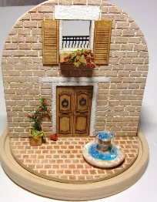
1:48 Scale Italian Villa Dome Vignette
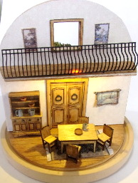
Items needed to complete project:
Q-tips
Denatured alcohol (optional for
cleaning “soot”)
Paper towels
Paint Brushes
Paint; terra cotta, dark orange, light orange, tan, light brown, white and others of your choosing
Wood stain
Sandpaper
Glue and gluing jig
Wallpaper Glue
Small sharp scissors & hobby knife
Tweezers
clamps

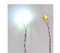
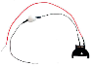
Items included in this kit:
Glass dome
Battery cell with LED Nano light

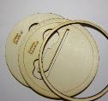
- 3 piece wood base with coin cell battery cut out
B. Center dome base with engraved
flooring – 1/16” maple
C. Center dome structure walls (one blank, one engraved bricks) – 1/8” liteply
A
D. Laser cut door frames (inside and outside) 1/32” maple
E. Laser cut window frames (inside and outside) 1/32” maple
F. Laser cut door overlays (8) 1/32” maple
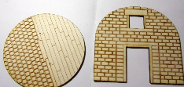
G. Engraved door pieces (2) – 1/16” maple
C
B
H. Laser cut shutters (2)
I. Window box kit – 1/32” maple
J. Door handles (2)
K. Second story balcony with engraved flooring and railing

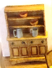
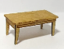
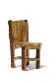
Kits:
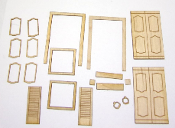
- Wood table kit
D
E
F
G
H
I
J
- Chair kits (4)
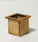
- Laser cut planter
- Cupboard kit

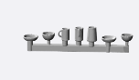
3D items:
Tankards and bowls
Fountain
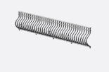
Balcony railing

Other:
Greenery
K
Grout
Wallpaper
Acedtate for window
1/16” Strip of wood for beams
Felt pads
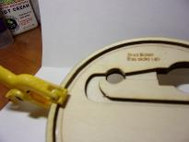
Please read all directions first including the tips that follow
I show pictures of the colors I chose but feel free to use colors of your choosing.
Directions:

Prepare and paint pieces.
Prepare laser cut wood for painting and staining
(see tips for working with wood.)

Glue three base pieces together-- the 2 marked and one ring,
making sure all the edges are flush especially the two cutouts
in the middle, they must be flush!, clamp and let dry.
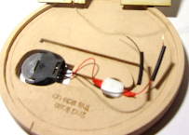
Lightly sand edges until smooth. Paint base pieces.
(I used tan), be sure to get inside the ring (it will show through glass)
and all along outside.

Fit the battery pack into the holes with the on/off switch facing
downward. Lightly sand if necessary to get snug fit. The battery
should sit nicely and not fall through the hole but be able to switch
out batteries when needed. Set aside.

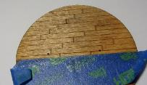
Stain wood pieces; half of first floor with engraved boards,
second floor balcony on the engraved side, door and door overlays.
Door and frames be stained or painted color of your choosing.

Paint under side of loft floor as a ceiling.

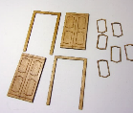
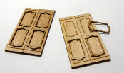
Glue door pieces back to back, clamp and let dry.
Glue overlay pieces in place.

Glue door handles in place. Let dry and set aside.

Paint dome structure outside brick wall as desired.
I used various tans, sand and light browns.

Use stiff brush to stipple color around bricks, blot with paper towel.

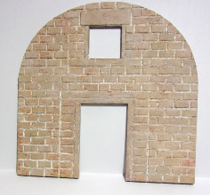
Build up colors until satisfied.

Be sure to paint inside of window edges and all along the outside.

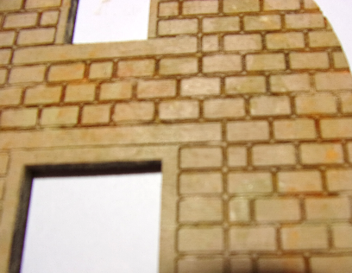
subtle “stipple” first coat
keep adding different colors

Mask off wood flooring from tiles with painter’s tape.

Paint terra cotta tiles using terra cotta and various
oranges and reds/ “Stipple” or “pounce” the paint colors
over the tiles you are satisfied, building up layers and depth
before wiping off
of color. Seal with sealer. Let dry.

Grout tiles and dome structure bricks with white or tan non-sanded grout mixed one part to one part. Paint the grout over the bricks letting it seep into the seams, gently wipe with damp paper towels pushing the grout into the seams and wiping clear of the tiles.

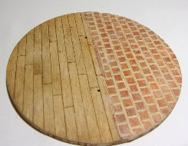
DO NOT GLUE IN PLACE YET!

Hole for wiring

Assembly:

Wallpaper interior wall.

Cut out window and door opening with hobby knife.

Glue acetate behind window opening.

Glue interior window and door frames;
The frames should be painted or stained first

Assemble window box and fill with greenery.

Lay center interior wall piece on a flat
surface and measure up 2” and mark
with pencil. This is where the balcony will be glued in place.

Fit doors in opening, you may need to sand a bit if the stain and paint have made the opening a bit to tight. Do not glue until final assembly.

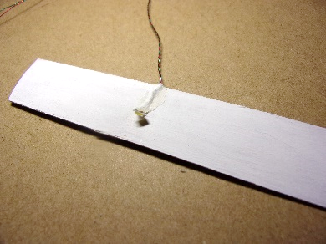
Lighting:

Make an overhead light by gluing bulb to bottom
side of balcony floor and glue wire to edge of floor
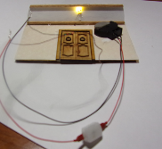
where it will be joined to the center piece.

Glue balcony floor in place and then run wire through hole
and down the inside wall of the first floor and through the
hole in flooring to base. You may wish to use one of the
beams to sit atop the wire where the floor and wall come
together. Then glue the remaining beam across underside
of balcony. Untwist bulb wire to separate the two colors.
Connect the wire from the bulb to the wire from the battery
and make sure the light works.
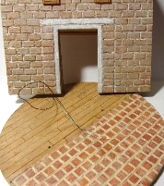

DO NOT GLUE IN PLACE.

Untwist wire and wait until final assembly to reconnect.

Glue balcony flooring in place at 2” mark.
Let dry.

Paint railing black.
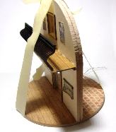
Glue railing along front of balcony.
You may want to clip tiny tabs to make it easier to glue.

Insert wire from light through the hole in flooring.

Glue center wall piece on top of floor along engraved line.

Use masking tape to hold in place while drying.

Slide shrink tube down the red wire and one down the black wire. Connect red wires together and twist. Repeat with opposite wire. Insert battery into holder and click switch. If the light does not come on, check the wire connections. Once satisfied with light use heat source on the shrink tube to secure. (It will melt down to encase the wire connection and help secure it.)

Insert coin holder into larger opening on the base, run along slot and insert on/off button into smaller hole with switch facing down. Run wires along remaining area of slot and secure in place.

Glue felt pads to bottom of base to raise it so that the light switch is not protruding past the entire piece. You want to be able to pick up the finished dome and click the on off switch underneath and it will not be seen from the finished dome vignette.

Furnishings:
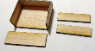
Assemble table and chairs as directed on packaging.
Paint or stain as desired.

Assemble cabinet, paint and stain as desired.

Paint 3D tankards and bowls as desired and arrange on table and in cabinet
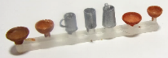

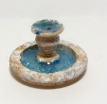
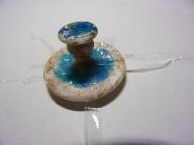
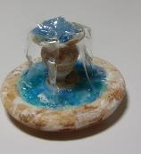
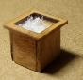
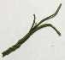

Fountain:
2.
1.

- Paint fountain. I used blue gallery glass
For water and white and tan acrylic for fountain.
You may coordinate the color of the fountain
with the walls colors you chose.

Cut thin strips of plastic wrap for the waterfall.
Use dimensional magic to adhere one end of
strips to the water in bottom of fountain.
Be sure to clean off any Dimensional Magic that
gets on outside rim.
33.
- Let dry for 10 minutes or until it is tacky.
Using a toothpick gently fold the strip of
plastic up into the top bowl of water. Cut any extra
and push down into a drop of Dimensional fabric to
adhere it to the top of fountain.

Repeat with other strips of plastic.

1.
Planters:
33.
2.
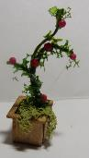
- Paint or stain planter.
I use a bit of Styrofoam inside to hold
plant in place.

- Cut wire and shape, twist wires together
then curve and trim wire.

- Glue landscape material to wire and
glue into planter. Add flowering material and flowers.
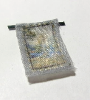

Finish Assembly:

Cut out the printies made from silk
fabric designs. Seal around the edges with
glue careful not to use too much that will
stain the fabric. You may wish to hang the
tapestries with a wire for hanger or glue
to wall like a picture.

Glue door in place.

Glue planters in place.

Arrange furniture and glue in place or use sticky putty or museum wax, whatever is your preferred way to adhere furniture in your projects.

Other ideas:
My inspiration
Add additional greenery and pots if desired.
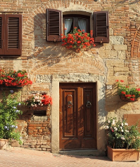
Add food to bowls on table

Thanks for purchasing this kit.
Be sure to send me a picture to post on my web site.

Your feedback and suggestions are welcome.

Shellie Williams
Mini Etchers
www.minietchers.com

Email: Swill123@aol.com

